PROJECT:
PLANTS VS ZOMBIES
COURSE: OBJECT-ORIENTED PROGRAMMING
INTERNATIONAL UNIVERSITY – VIETNAM NATIONAL UNIVERSITY HCMC
School of Computer Science and Engineering
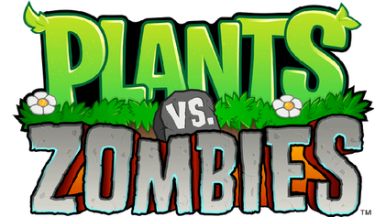

GROUP: 4 anh em siu nhân

No. | Name | Student ID
1. | Lê Đức Huy | ITITIU23030
2. | Trần Quốc Bảo | ITITWE20033
3. | Trần Kim Vinh | ITITIU23029
4. | Nguyễn Thành Tài | ITITIU23023

The project aims to develop a strategic tower defense game modeled after the classic game "Plants vs. Zombies" (PvZ). The game challenges players to strategically deploy units to fend off waves of zombies to protect the player character from having their brains eaten. The primary goal is to provide engaging gameplay while demonstrating the principles of Object-Oriented Programming (OOP) through the game's design, architecture, and implementation.

Table of Contents

Chapter 1. Introduction
1.1 About the project: 3
1.2 Properties of the game: 3
Chapter 2. Methodology
2.1 The entities: 4
2.1.1 The plants: 4
2.1.1.1 The Plant class: 4
2.1.1.2 The Peashooter class: 4
2.1.1.3 The Pea class: 5
2.1.1.4 The FreezePeashooter and FreezePea classes: 6
2.1.1.5 The Walnut class: 7
2.1.1.6 The CherryBomb class: 8
2.1.1.7 The Sunflower class: 8
2.1.1.8 The UML model for the plant entities: 9
2.1.2 The zombies: 9
2.1.2.1 The Zombie class: 9
2.1.2.2 The NormalZombie class: 11
2.1.2.3 The ConeHeadZombie class: 11
2.1.1.4 The UML model for the zombie entities: 12
2.1.3 Miscellaneous: 12
2.1.3.1 The Plant class: 12
2.2 The GUI and other crucial classes: 13
2.2.1 The Collider class: 13
2.2.2 The GamePanel class: 14
2.2.3 The LevelData class: 16
2.2.4 The Menu class: 17
2.2.5 The sound class: 18
2.2.2 The Sun class: 19
2.2.3 The GameWindow class: 21
2.2.4 The GUI and other crucical classes UML model: 22
2.3 The complete UML model: 23
Chapter 3. The complete game
3.1 Begin the game: 24
3.2 Main game: 24
3.2.1 The Top left corner: 24
3.2.2 The Right side: 24
3.2.3 The Playing Field: 25
3.2.4 Gameplay tips: 25
Chapter 4. Experience
4.1 Lessons learned: 26
4.2 Reflections on game development: 26

Chapter 1. Introduction
  - About the project:
The project serves as an important practice for our team to delve into the principles of Object-Oriented Programming. Our goal is to faithfully re-implement the core aspects of the original game through the use of the Java language, all whilst practicing OOP principles.

As this project was specifically designed using the Java language, incorporating Object-Oriented Programming, we have effectively resolved several issues that commonly arise when using the traditional Procedural-Oriented Method:
● The code becomes more transparent, easily understandable, and concise.
● The project represents a cohesive logical system, achieved by combining numerous related classes.
● Each class contains multiple methods that perform distinct behaviors
unique to that class.

We chose PvZ as a base for the project because the simple fact that: it aligns with our personal interests, and that it does an amazing job at showcasing the importance of OOP in the development of programs. Through the combinations of classes and objects that share various similarities, we can visualize the path of development for the game easily. For example, towers in PvZ, also known as flowers, can all share a common parent class, simplifying the development of the project.

  - Properties of the game:
The goal of the game is to defend the player character’s house from a zombie-infested neighborhood using various plants, which can be deployed using sunlight. These plants can serve a multitude of jobs: generate more sunlight, attack enemies, weaken the enemies, or sacrifice itself on the front line to tank enemy attacks.

As the project’s goal is to faithfully re-implement the game in Java, we will plan to build a framework to help easily invent new objects or classes, rather than actually implementing many new things ourselves. In the project, we have implemented a few classes to properly showcase the extent of what our framework can do.

Chapter 2. Methodology

2.1 The entities:

2.1.1 The plants:
2.1.1.1 The Plant class:
- It serves as the parent class for every plant entity moving forward, and encapsulates common attributes such as: health and position.
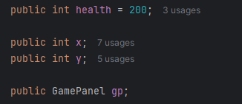
1.Basic parameters of Plant

- Includes a constructor method to simplify the code of the classes that inherit this one.
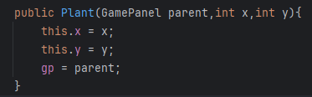
2.Constructor to simplify the code

- Includes an empty stop() method, which helps handle certain special processes that may happen when a plant dies or disappears.

2.1.1.2 The Peashooter class:
A subclass of the Plant class. A very familiar plant, commonly considered the face of the game itself. It features the following:
- Utilizes the Java AWT and Swing libraries to function
- A Timer class shootTimer variable to handle the interval between each attack of the plant
- A constructor method that also handles the inner working of the plant:
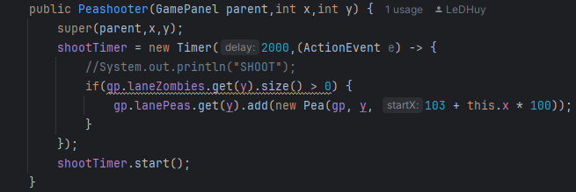
3.Constructor of class Peashooter
In particular, the constructor accepts three variables: panel in which the game runs, as well as the positional variables.
Upon construction, a new shootTimer variable is created with the interval 2000ms (or 2 seconds), which includes a lambda expression that instructs the work of the Peashooter class. Upon the timer expiring, the following will happen:
- The plant will check to see if there are any zombies inside its lane.
- If there is a zombie, fires a Pea class object projectile. The position of the pea object will be based on the y position of the Plant, and the x calculated using the following formula: x = 103 + plant’s x position*100.
- Overrides the parent stop() method to deactivate the timer as soon as the method is called.
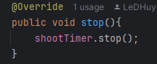
4.Ovverides the method stop

2.1.1.3 The Pea class:
This class handles projectiles that are fired by the Peashooter class. It includes the following:
- Basic attributes such as the horizontal position, the lane in which it belongs (handles vertical position), and a GamePanel variable gp which allows the object to interact with the other parts of the game.
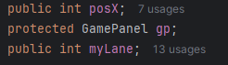
5.Basic parameters of Pea
- A basic constructor that accepts 3 variables: the panel in which the game runs, the lane in which the projectile belongs, and its starting horizontal position.
- An advance() method which handles most of the Pea object’s job.
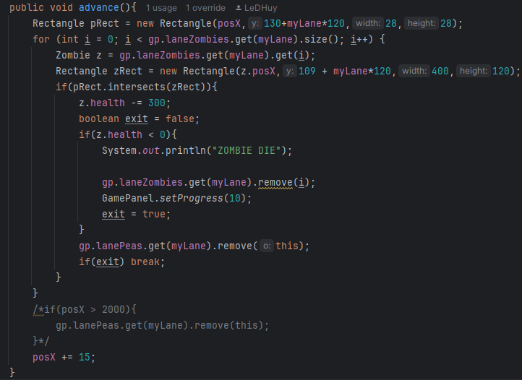
6.Advance method of class Pea
In particular, the method starts out by creating a 28x28 pixel hitbox for the projectile, which is integral for checking its collision with zombies.
The x position of the object will be based on its constructor. Whereas the y position will be calculated with the following formula: 130 + myLane*120.
After that, the following will happen:
- The projectile scans for each Zombie that exists within the lane.
- Creates a 400x120 pixel hitbox for each zombie.
- Utilizes the Rectangle class’s intersects() method to check for collision between the projectile and the zombie.
- Upon collision, the zombie’s hp is deducted by a flat 300 hp value.
- Declares an exit variable to control the loop. It exits the loop when the zombie has died, ensuring the code doesn’t continue checking other zombies after this one dies.
- Adds ten points to stage progress when a zombie dies.

2.1.1.4 The FreezePeashooter and FreezePea classes:
A special variant of the Peashooter plant that shoots a different projectile that has the ability to slow down zombies upon landing. Structurally identical to the Peashooter class, but shoots a FreezePea projectile instead.
Upon collision, the FreezePea Projectile does damage and causes the Zombie to slow down. This slow effect does not stack upon each other. Here’s the relevant code segment in particular:
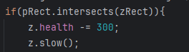
7.Special variant of Freeze

2.1.1.5 The Walnut class:
A subclass of the Plant class. It doesn’t have any special abilities, but it possesses a health pool that is much larger compared to other plants. It features the following:
- A constructor that modifies it’s HP (hit point) to a value that’s 10 times higher than the rest of the plants.
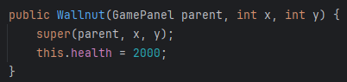
8.Constructor of class Wallnut
- The stop() method is empty, as the Walnut does not have any special abilities.

2.1.1.6 The CherryBomb class:
A subclass of the Plant class. Appearance is reminiscent to that of a cherry fruit. It explodes after a short duration from its deployment, instantly eliminating every zombie in a 3x3 radius. It features the following:
- A constructor that includes the basic stuff, and also begins a countdown to its detonation.
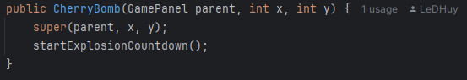
9.Constructor of class CherryBomb
- The countdown method, preset to trigger the explode() method in 2000ms, or 2 seconds.
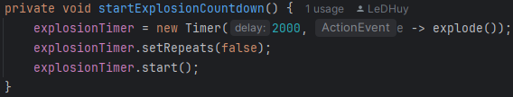
10.Method to countdown explode
- The explode() method, which eliminates every zombie in a 3x3 grid radius.
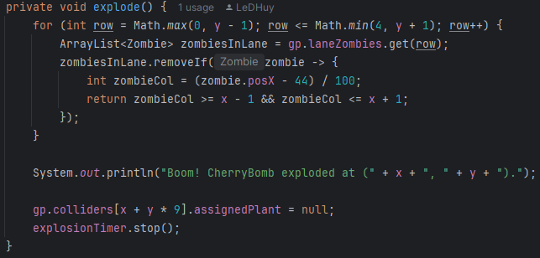
11.Expode method of class CherryBomb
In particular, the loop selects all zombies within the three rows: the y row, the row above (y - 1), and the row below (y + 1). In Swing, the y-axis coordinates follow this logic: y - 1 is the row above, and y + 1 is the row below.

zombie.posX represents the x-coordinate of the zombie, measured in pixels, on the game board. Subtracting 44 is necessary because on the game board, the first column does not start at 44 but at 0. The subtraction ensures the zombie's exact position in pixels is determined. Dividing by 100 is required because each cell on the game board is 100 pixels wide. This division identifies the exact column number of the zombie on the game board.

After the explosion, the cherry bomb is removed from the game board. To identify the grid cell of the cherry bomb, the x-coordinate is added to the product of the y-coordinate multiplied by 9. The game board has 9 columns, with each row occupying 9 positions in a 1D array. Multiplying y by 9 determines the row the cherry bomb is in, and adding the x coordinate pinpoints its exact position. Once identified, the cherry bomb is removed.

2.1.1.7 The Sunflower class:
A subclass of the Plant class. Serves as a vanguard unit that generates sunlight to accelerate the deployment of stronger, more expensive flowers. It features the following:
- A Timer variable preset at 15000ms, or 15s. Meaning that it will spawn one instance of a Sun object every 15 seconds.
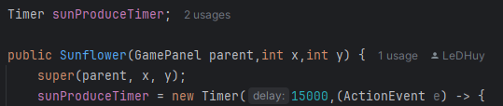
12.Timer variables to preset time
- A constructor that initializes a Sunflower instance at the specified position on the game board and immediately starts the timer to generate Sun objects periodically.
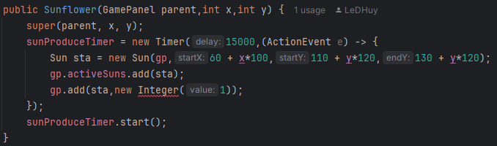
13.Constructor of class Sunflower
This method creates a Sun object at a calculated position based on the sunflower’s grid location, then adds the Sun object to the activeSuns list in the GamePanel, ensuring it becomes a interactable resource for the player. The sun is also visually added to the game interface via the add() method.

2.1.1.8 The UML model for the plant entities:

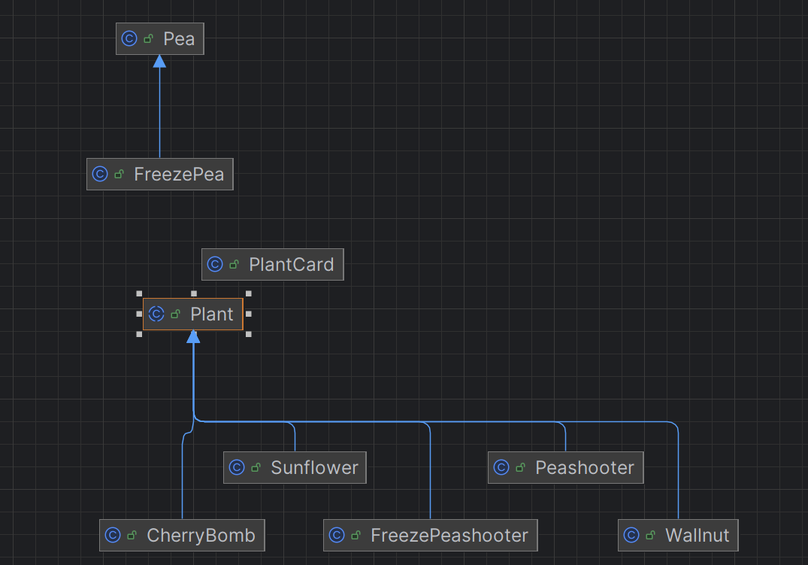
14.UML of Plant Entities

2.1.2 The zombies:

2.1.2.1 The Zombie class:
- It serves as the parent class for every zombie entity moving forward, and encapsulates basic attributes such as health, position zombie behavior such as movement, interaction with plants, and special interactions (e.g., slowing down when affected by specific attacks). The class is designed to be extendable, allowing for different types of zombies with unique characteristics.
- Includes a constructor that initializes a new Zombie object and links it to the GamePanel, allowing it to interact with other entities.
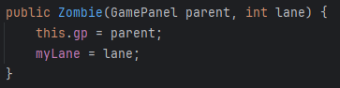
1.Constructor of class Zombie

- The advance() method manages the zombie’s movement across the board. It can check for collisions with plants in its lane using the Collider class. If a collision occurs, the zombie reduce the plant’s health. Otherwise, it continues moving forward.
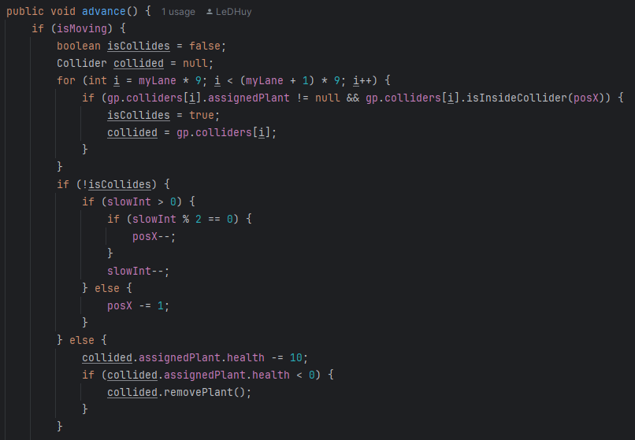
2.Advance method
Additionally, if the zombie reaches the end of the board (posX < 0), it is game over.
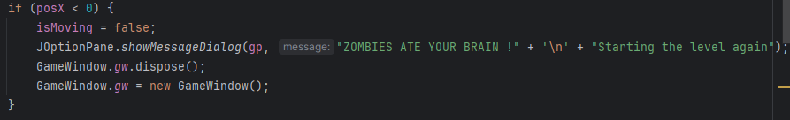
3.Code when player lose

- Also includes a slow() method, which slows the zombie down for a preset amount of time.
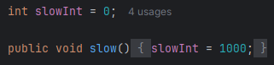

- And lastly, the getZombie() factory method, which dynamically creates specific zombie types based on a string parameter. This approach ensures scalability when introducing new zombie types.
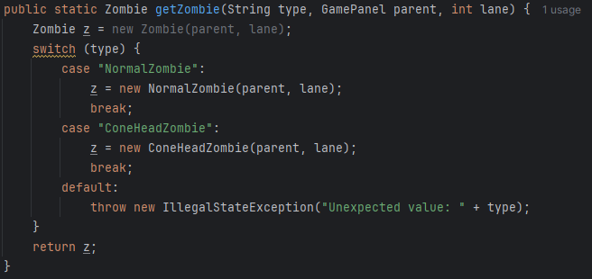
4.getZombie method

2.1.2.2 The NormalZombie class:
A subclass of the Zombie class, constructed with no difference from the main Zombie class. However, it must be created to enable code reuse and simplifies the addition of new zombie types by focusing on unique behavior on subclasses. It is merely no more than to demonstrate the effective use of OOP principles such as polymorphism and encapsulation.
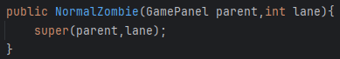
5.Constructor of class NormalZombie

2.1.2.3 The ConeHeadZombie class:
A subclass of the Zombie class, constructed with minor differences from the main Zombie class. In particular, this specific zombie type differs from the NormalZombie by having a larger healthpool, making it more resistant to attacks. This design introduces an added layer of challenge for players, requiring more strategic resource allocation to defeat tougher enemies. In a nutshell, it serves as a difficulty scaling option by visually making the NormalZombie different, instead of simply boosting the values of its attributes.
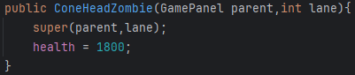
6.Constructor of class ConeHeadZombie

2.1.2.4 The UML model for Zombie entities:
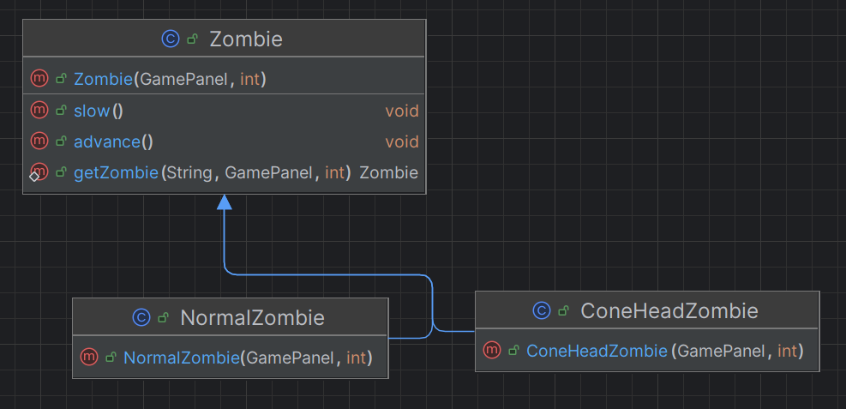
7.UML of Zombie Entity

2.1.3 Miscellaneous:
2.1.3.1 The PlantCard class:
The PlantCard class represents a user interface (UI) component in the game that allows players to select plants for placement on the game board. It extends the JPanel class from Swing, providing a graphical representation of plant cards and handling mouse interactions for player actions. By integrating images and event listeners, the PlantCard serves as a bridge between the player and the gameplay mechanics. It features the following:
- A constructor that initalizes a PlantCard instance with a specific image attached and prepares it to handle mouse interactions.
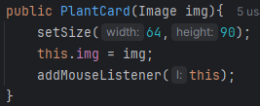
1.Constructor of class PlantCard

- A setAction() method that assigns an ActionListener to the card, enabling it to trigger a specified action when clicked. This allows the player to select aplant for placement on the game board.
2.SetAction method

- A paintComponent() method that overrides the same method from JPanel to draw the plant card’s image on the UI.
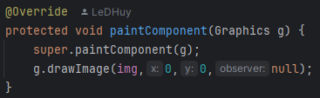
3.paintComponent method

2.2 The GUI and other crucial classes:
2.2.1 The Collider class:
The Collider class represents a grid cell on the game board that manages interactions between entities and player actions. It serves as a key component in collision detection, plant placement, and user interaction. Extending JPanel, the Collider handles graphical representation, event listening, and object management, making it an essential for coordinating gameplay mechanics. It features the following:
- Encapsulates a few attributes such as the ActionListener variable or a reference to the Plant object assigned to this collider.
- A constructor that initializes the Collier with default settings, preparing it for interaction and rendering. It immediately sets the size of the collider to 100x120 pixels, matching the grid cell dimensions, and configures the collier to be transparent, then adds a mouse listener for interaction handling.
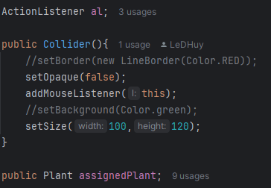
4.Constructor of class Collider
- A setPlant() Method that assigns a Plant object to the collider, effectively placing the plant in the current grid cell. As well as a removePlant() method, which removes the assigned plant by caling its stop() method to halt any ongoing behaviors (such as timers) and setting assignedPlant to null.
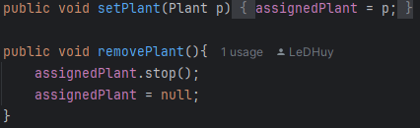
5.SetPlant method and removePlant method

- A isInsideCollider() method that checks whether a given x-coordinate falls within the collider’s bounds. This is used for detecting whether a zombie’s position overlaps with the collider.

- A setAction() method that assigns an ActionListener to handle specific actions triggered by mouse interactions on the collider.

2.2.2 The GamePanel class:
The GamePanel class is the central component of the game’s user interface and gameplay logic. It manages the rendering of game elements, user interactions, and game mechanics such as plant placement, zombie movement, sun generation, and level progression. Extending JLayeredPane, it provides an interactive space for players to strategize and respond to the game’s challenges. It features the following:
- Core attributes includes:
- Images: Stores graphical assets for the game’s background, plants, zombies, projectiles, and other elements.
- Game Objects: stores colliders. Stores laneZombies and lanePeas which manages zombies and projectiles for each of the five lanes. And stores activeSuns to track Sun objects available for collection.
- Timers: Control game updates and object spawning at fixed intervals, such as the redrawTimer() for refreshing the screen and the sunProducer() for generating suns.
- Player State: sunScore, which tracks the player’s current sunlight currency. And activePlantingBrush, which keeps track of the currently selected planted type for placement.
- A constructor that initializes the game panel with essential components such as images, timers, and data structures for game elements.
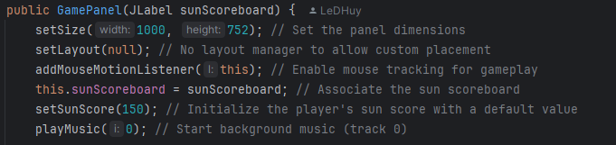
6.Constructor of class GamePannel
(and more, but the constructor is too long to be shown in a report)

- Gameplay Mechanics are handled as per the following:
- Plant Placement: Handled by the PlantActionListener inner class, which places the selected plant in the appropriate grid cell if the player has enough sunlight currency. Example: for the Sunflower plant:
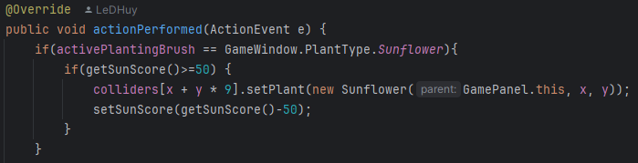
7.ActionPerformed method

- Zombie Spawning: Zombies are spawned periodically using the zombieProducer timer. The actionPerformed method selects a random lane and zombie based on level configuration.
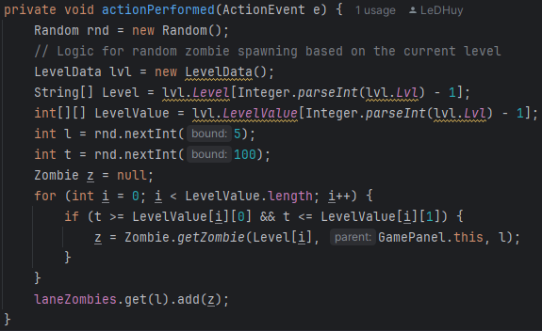
8.ActionPerformed method

- Sun generation: Suns are created at random positions every 5 seconds using the sunProducer timer.
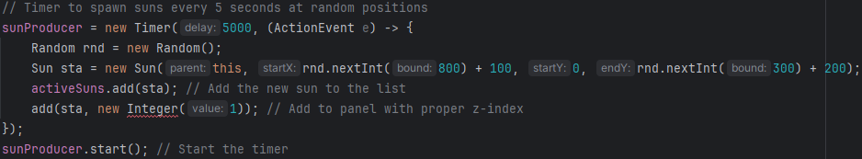
9.Code to set Sun generation

- Game Object Updates: the advance() method updates the positions of zombies, projectiles, and suns in each lane at regular intervals. For example:
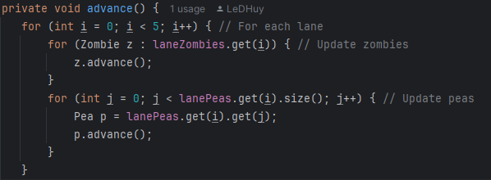
10.Advance method

- Rendering: The paintComponent method renders the background, plants, zombies, and projectiles on the screen. For example:
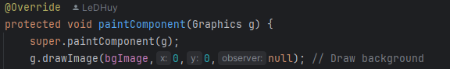
11.Ovveride paintComponent method
2.2.3 The LevelData class:
The LevelData class manages the game’s level system, including level configuration and progression. It defines the types of zombies encountered in each level, their spawn probabilities, and the current level state. This class ensures that level-related data is stored and retrieved consistently, allowing players to enjoy the game seamlessly. It features the following:
- Core Atttributes include:
- Lvl: tracks the current level as a String. Defaults to “1” as players start at the first level.
- Level: A 2D array that specifies the types of zombies available in each level.
- LevelValue: A 3D array defining the probability ranges for each zombie type in each level.
- A constructor that initializes the LevelData class by reading the current level from a file (Level.vbhv). If the file does not exist, it creaes the file and sets the default level to one.
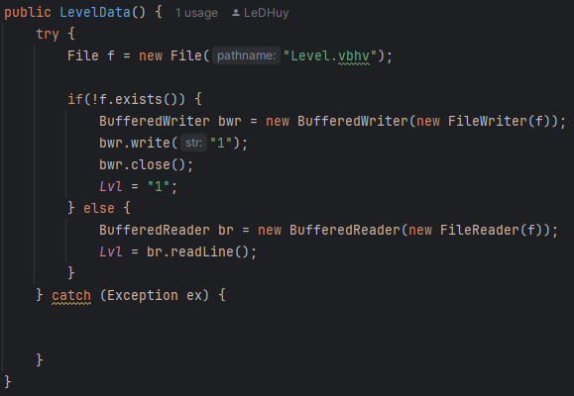
12.Constructor of class LevelData

- A write() method that writes the specified level value (lvl) to the Level.vbhv file, ensuring persistence across sessions. Updates the Lvl attribute to reflect the new level.
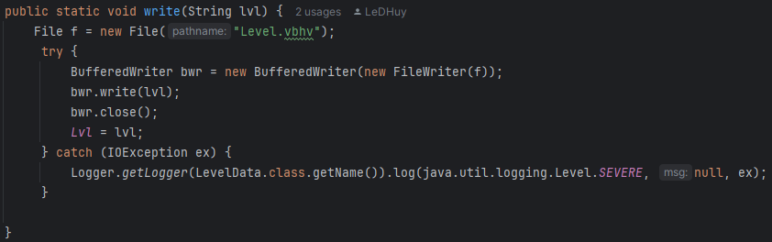
13.Write method

2.2.4 The Menu class:
The Menu class represents the main menu interface for the game. It provides players with an entry point to start the game, displaying the background image and responding to mouse interactions. Extending JPanel, this class combines Swing’s GUI features with custom graphics rendering to create an interactive main menu with good visual clarity. It features the following:
- Core Attributes include:
- bgImages: an Image object that represents the menu’s background image. Loaded using ImageIcon from the resources/images/main/menu.png file.
- jPanel1: a sub-panel that detects mouse clicks, used to trigger game startup.
- A constructor that initializes the menu panel, setting its size, loading the background image, and configuring its layout.
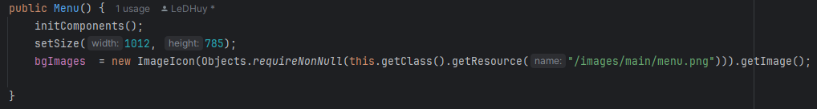
14.Constructor of class Menu

In particular, this method calls the initComponents() method to set up the sub-panel jPanel1 and its layout. Configures the panel size to 1012x785 pixels, then grabs the image from the file.
- A paintComponent() method that overrides the same method from JPanel to render the background image onto the menu panel. Uses the Graphics object to draw the image starting from the top-left corner (meaning it fills the entire screen).
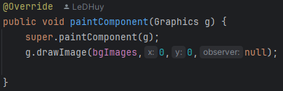
15.Ovveride paintComponent method

- A initComponents() method that initializes jPanel1 and configures its behavior. Sets jPanel1 as transparent and adds a mouse listener to detect clicks, then defines the panel’s layout and adds it to the main menu panel.
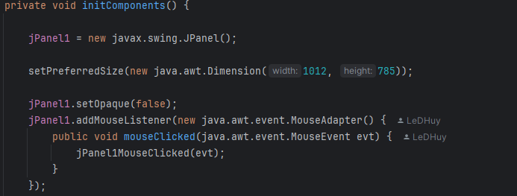
16.InitComponets method
(And more, but the method is too long to fit in one image)

- A jPanel1MouseCLicked() method that triggers when the player clicks on jPanel1. Upon being triggered, it will call the static method GameWindow.begin() to start the game.
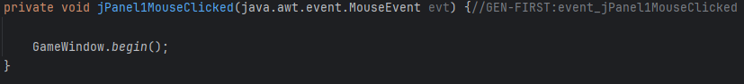
17.To set GameBegin by MouseClicked

2.2.5 The sound class:
The sound classis responsible for managing the game’s audio, including background music and sound effects. It uses Java’s javax.sound.sampled package to load, play, loop, and stop audio files. This class allows for seamless integration and control of sound effects and music in the game.
- Core attributes include:
- clip: An instance of the Clip class, used to play audio files.
- soundURL[]: An array of URL objects that stores paths to audio files. Supports up to 30 audio files, with each indexed for easy retrieval.

- A constructor that initializes the sound class and loads audio file paths into the soundURL array. For example:
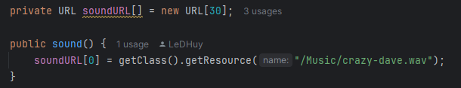
18.Constructor of class sound

- A setFile() method that loads the audio file at index I from the soundURL array into the clip object, also handles cases where the audio file does not exist.
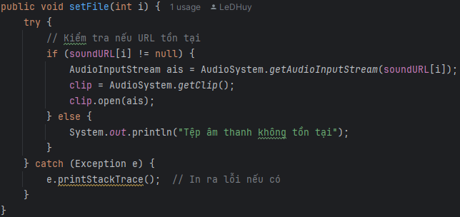

- A play() method that starts playback of the loaded audio clip. Prints a warning message if no clip has been initialized.
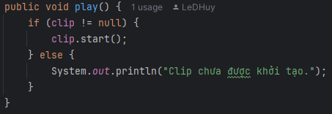

- A loop() method that plays the audio clip in a continuous loop.
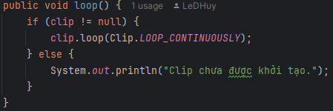

- A stop() method that stops playback of the current audio clip.
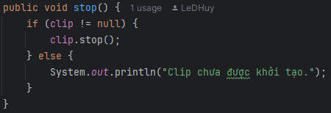

2.2.6 The Sun class:
The Sun class represents collectible sun objects in the game, which serve as the player’s currency for deploying plants. Extending JPanel, this class is responsible for rendering the sun’s visual representation, managing its movement on the screen, and handling player interactions.
- Core Attributes include:
- gp: A reference to the GamePanel instance that manages the game state, including the collection of active suns.
- sunImage: an Image class object representing the visual appearance of the sun, loaded from the /images/sun.png resource.
- myX and myY: represent the coordinates of the sun on the screen.
- endY: final vertical position where the sun stops falling down.
- destruct: a countdown timer for automatic garbage disposal of suns. Prevents there from being too many suns at once on the screen.
- A constructor that initializes a new Sun object with its starting and ending positions, sets up the image and interactivity, then links it to the GamePanel.
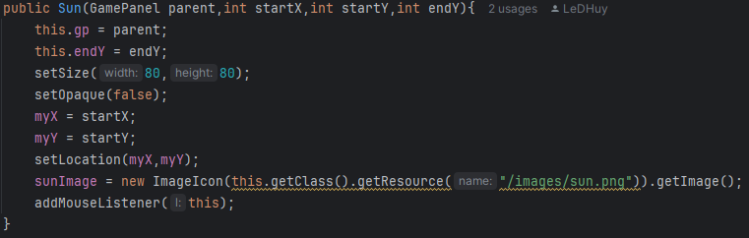
19.Constructor of class Sun

- A paintComponent() method that overrides the same method from JPanel to render the sun image on the screen.
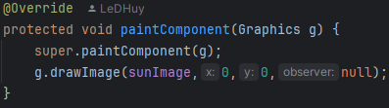
20.Ovveride paintComponent method

- An advance() method that handles the sun’s movement and lifetime. If the sun has not reached endY, it descends by 4 pixels per screen refresh (also known as per frame). Once it reaches endY, the destruct timer begins, and the sun is disposed if it remains uncollected for long enough.
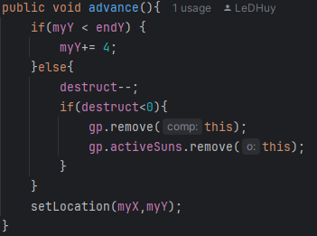
21.Advance method

- A mouseReleased() method that increases the player’s sunlight currency by 25 when the player clicks the Sun object. Immediately removes the Sun from the game board and the list of active suns after this interaction.
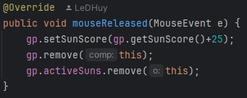

2.2.7 The GameWindow class:
The GameWindow serves as the main application window for the game. It initializes and manages the game’s UI components, including the main menu, gameplay panel, and others. Extending Jframe, this class provides a flexible framework for rendering components and handling transitions between gameplay and menu screens. It features the following:
- Core attributes include:
- PlantType: An enumerated type representing the different plants available for deployment.
- gw: A static reference to the current GameWindow instance, allowing for transitions between states. For example: from the menu screen to the gameplay screen.
- A constructor that initializes the gameplay interface, including the game panel, sunlight currency label, and plant cards for selection. Configures the layout using a JLayeredPane to manage overlapping components. Then sets up action listeners for plant cards to update the active planting brush in the game panel.
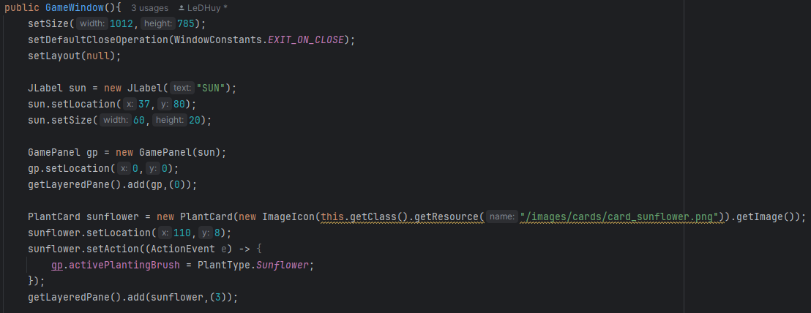
22.Constructor of class GameWindow
(And more, but the method is too long to fit in one image)

- Another constructor that initializes the menu interface by adding a Menu instance to the JLayeredPane.
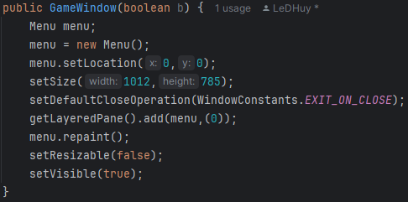
23.Anorther constructor of class GameWindow

- A begin() method that disposes of the current window and initalizes a new GameWindow for gameplay. In other words, it helps the current window goes from the main menu to the main game window.
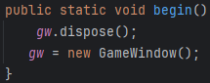

- A main() method that determines the class as the main class that launches the application by initializing the menu interface.
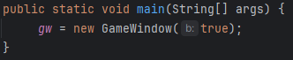
24.Main method of Game

2.2.8 The GUI and other crucial classes UML model:

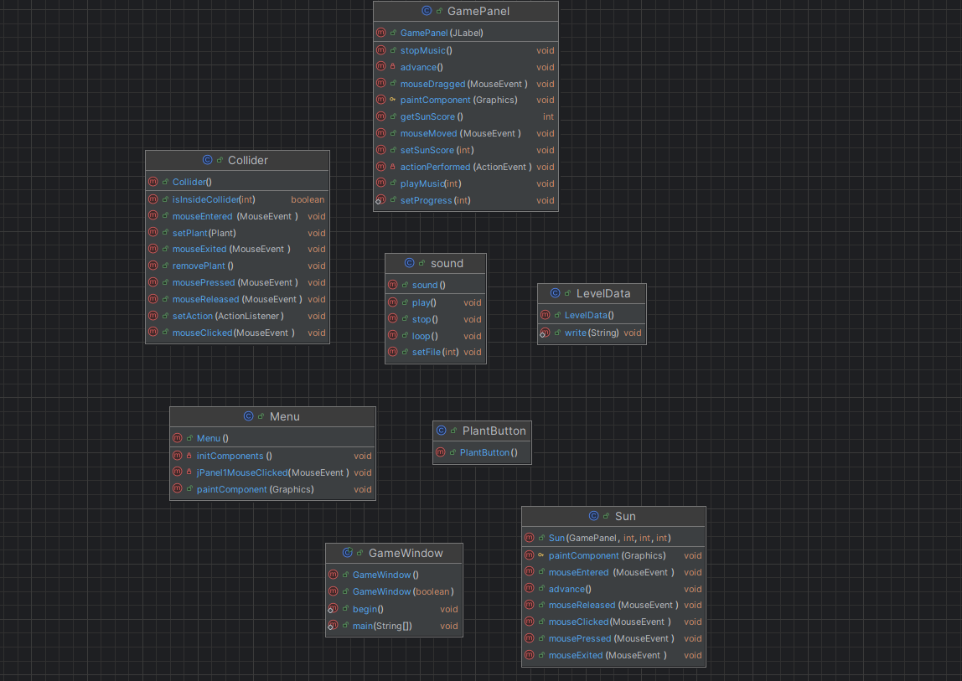
25.UML of GamePlayandGUI

2.3 The complete UML model:

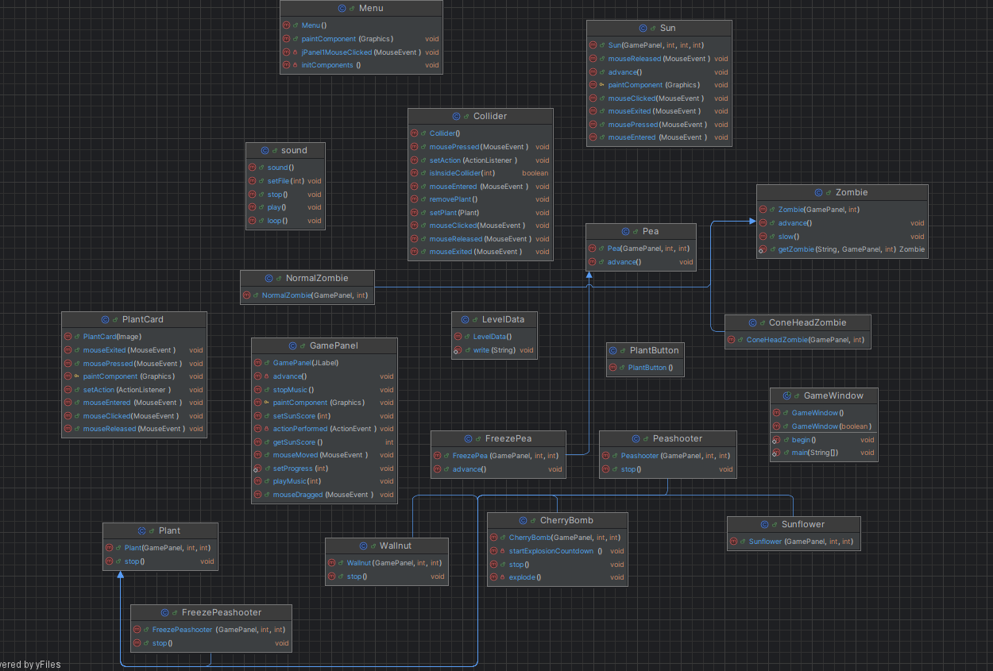
26.UML of Game

Chapter 3. The complete game

The source code:
https://github.com/LeDHuy/FINALNE
Video game demo:
https://www.youtube.com/watch?v=4YQv5_7OSgI

Game Instructions:

3.1 Begin the game:
Click on play to enter the main game window. Other buttons are currently placeholders and do not function.
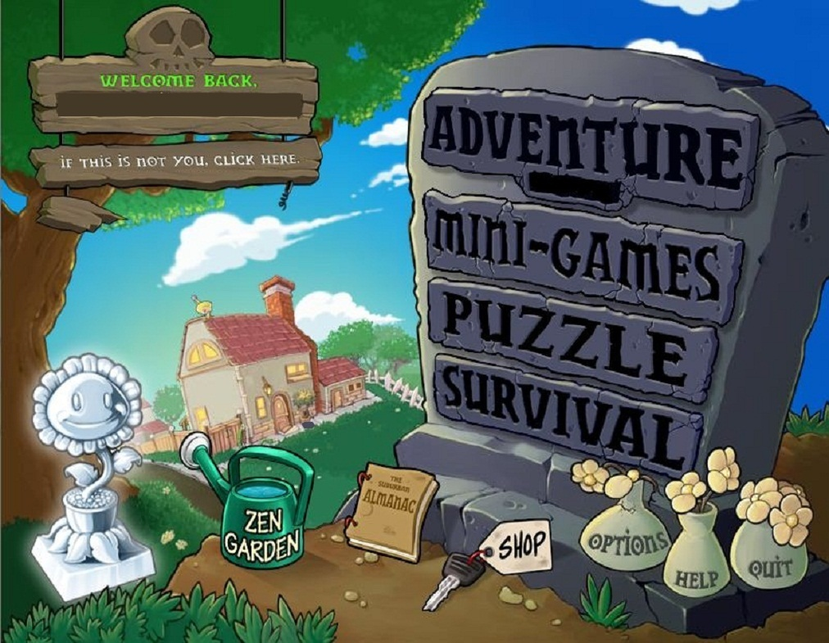

3.2 Main game:

3.2.1 The Top left corner:
Here lies the UI where you may find your current sunlight currency value, as well as the cards of the plants you may deploy.
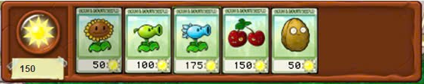
The game starts with 150 sunlight immediately available for you to use. To get more sunlight, you have to collect them as soon as they naturally spawn on the map, or deploy sunflowers to spawn them periodically.

3.2.2 The Right side:
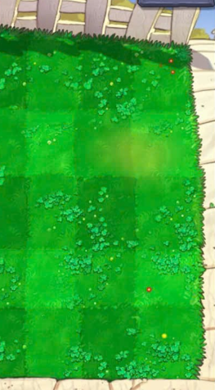
From here, enemies (zombies) emerge, your job is to defeat them before they can reach the left side of the screen, where they will defeat you and eat your brains.

3.2.3 The Playing Field:
The main playing field is a 9x5 grid based platform, you may deploy your flowers on any of these tiles, after which they will start working.
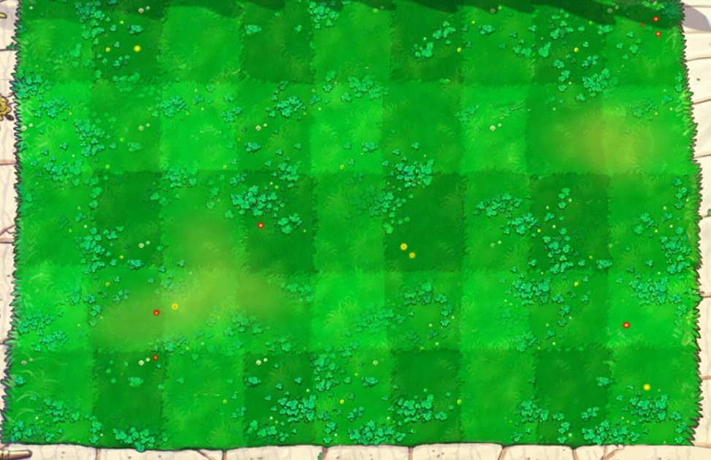

3.2.4 Gameplay tips:
- Immediately after the game starts, you should deploy 3 sunflowers to cover for the slow natural sun generation. Protect these flowers as they cannot attack, and are quick to die from enemy attacks. To protect them, you should place them at the far back side of the screen (far left).

- If faced with fast but weak enemies immediately after the game starts, you should sacrifice some sunflowers to deploy a peashooter. Peashooters are weak plants that do low damage, has low health and have no special effects. However, they’re cheap and suited for early-game combat.

- After awhile, you may find yourself with a surplus of sunlight energy, use them to deploy stronger plants such as these three:
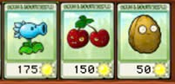
They work excellently together:
The Freeze Peashooter can slow down enemies upon firing at them, and the Walnut can stall enemies for longer. Both plants can cause zombies to eventually group up in one place.
After a great concentration of zombies are in a small part of the field, you may deploy the Cherry bomb to effectively clear out the entire group of enemies.

Chapter 4. Experience

4.1 Lessons learned:
Working on this project has taught us that creating a game is a multifaceted endeavor that extends far beyond just writing code. While the software forms the backbone, a game becomes truly engaging when it incorporates well-crafted content, such as its environment, storyline, gameplay mechanics, artwork, and animations. These elements combine to create a cohesive and enjoyable player experience.

Over the course of this project, we had the opportunity to apply many of the lessons we learned in class, from fundamental OOP principles to problem-solving strategies. Debugging was a significant part of the journey, and dealing with various bugs helped us improve our critical thinking and troubleshooting skills. Additionally, the project pushed us to explore topics beyond the classroom curriculum, encouraging self-study and deeper dives into technical resources, which expanded our knowledge and experience.

4.2 Reflections on game development:
This process reinforced the idea that success in Computer Science depends heavily on self-driven learning. The field is vast and constantly changing, requiring us to continuously adapt and acquire new skills. Completing this project not only solidified our understanding of core programming concepts, but also gave us invaluable insights into collaborative development, game design, and user experience. Looking ahead, we would love to refine this game further and explore new platforms like mobile apps, creating engaging and impactful projects for a broader audience.

